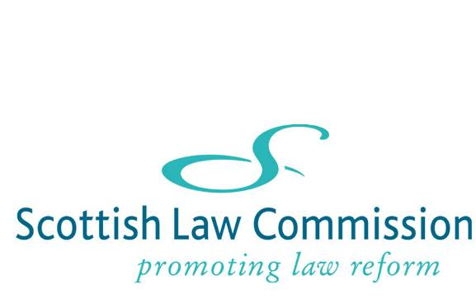
13 November 2012

Dear Colleague

SEMINAR ON EXECUTION IN COUNTERPART: THURSDAY 29 NOVEMBER, 4:45-6:15PM
CONSIDERATION OF DRAFT SLC LEGISLATION

The Scottish Law Commission is currently considering what recommendations to make on the law relating to execution of contracts in counterpart. We are told that this is an issue which causes great concern in practice for Scots lawyers.

The review forms part of our work on the law of contract, and particularly of formation of contract on which we published a Discussion Paper in March of this year. It is available on our website at http://www.scotlawcom.gov.uk/index.php/download_file/view/984/129/.

We have decided to publish a Report focussing on execution in counterpart and we aim to do so early next year. It will include a short draft Bill giving effect to our recommendations. The current draft is attached (but, as it is a working draft, I would be grateful if you would regard it as confidential until we publish our report).

In order to discuss our proposed approach we have organised a seminar on Thursday 29 November in conjunction with the University of Edinburgh. Full details are on the enclosed flier. I would be delighted if you were able to attend and to contribute your views. I would urge at least one representative of your firm to come, if at all possible. The views of those attending the seminar, together with any written comments we receive either before or within a short time after the event, will be very useful for us. (We may make an audio recording of the seminar for our own internal use but, if so, the Chatham House rule will apply. If anyone has any concerns about this please let me know.)

If the law is to be changed so as to facilitate execution in counterpart under Scots law we need to demonstrate to the Scottish Ministers that our recommendations are both sound and widely supported. I therefore invite you, or your colleagues, to register for the seminar and to help us put forward a powerful case for reform as soon as possible.

We would be grateful for an early response. If you have any questions please contact me or the Project Manager, Charles Garland (charles.garland@scotlawcom.gsi.gov.uk).

Yours sincerely,

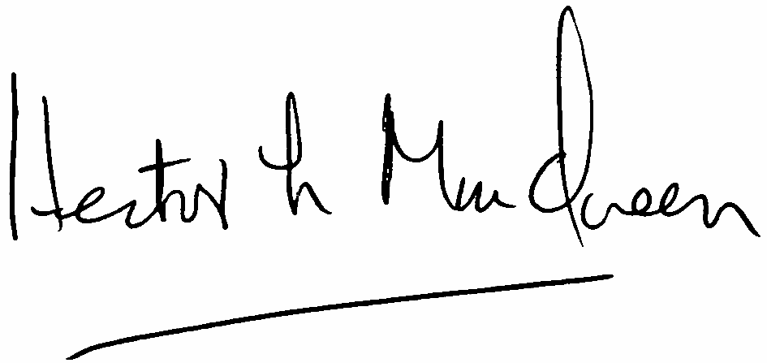

HECTOR MACQUEEN
Hector.macqueen@scotlawcom.gsi.gov.uk

