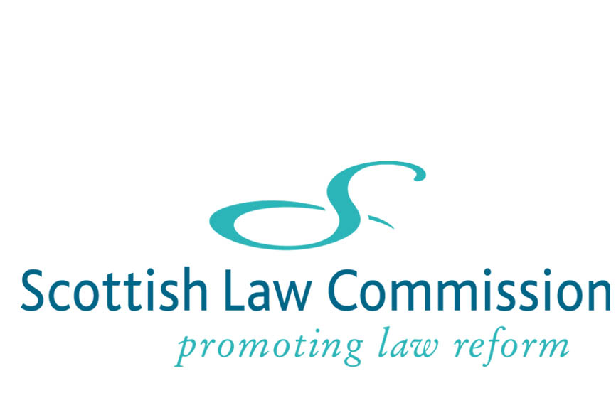

Life as a legal assistant
The Scottish Law Commission's role is to recommend reforms to improve, simplify and update Scots law. In recent years the Commission has considered reforms in a variety of areas including criminal law, family law, contract, electoral law, property and trust law. As a legal assistant, you will be given the opportunity to engage in this stimulating and challenging legal work, and gain a unique insight into the process of law reform.
When you begin work, you will be assigned to one or two Commission projects and will work with a Project Manager and Commissioner as a valued member of a team. Both through internal work with your team and meetings with interested parties, you will work with leading solicitors, advocates and academics, members of the judiciary and parliamentary counsel in recommending changes to the law.
Depending on the stage your project has reached, you may find yourself carrying out the initial research on the present law, identifying problems and looking to other jurisdictions for possible solutions. You may also help in drafting discussion papers, evaluating and summarising consultees' responses to the discussion papers, and in drafting reports and explanatory notes to draft Bills. You will provide administrative support for the team; and also be involved in team, Commission and external Advisory Group meetings, the latter often attended by accomplished professionals from the legal world or beyond.
Throughout your time at the Commission you will be actively encouraged to express your own views and ideas in relation to your projects. Your level of responsibility on the tasks assigned to you will increase as the year progresses. The work is challenging and mentally stimulating, but working as part of a team means there is always supervision, encouragement and support when you need it. You will also benefit from an induction day and on-the-job training.
The office environment of the Commission is relaxed and friendly and the working hours are sensible. You will share an office with one or two other legal assistants. Each legal assistant has her or his own desk, PC and access to a wide range of databases and internet resources. The Commission also benefits from an extensive specialised library.
Our assistantships are suited to recent graduates, of both undergraduate and postgraduate degrees, and recently qualified lawyers seeking a new direction in their career. The positions offer an excellent opportunity to begin or build upon a variety of legal careers. Former legal assistants have gone on to successful careers as solicitors, in the private and public sectors, in the UK and overseas, as an advocate, and as academic lawyers. To find out more, call the Commission (0131 668 2131) and ask to speak to one of the current legal assistants.

