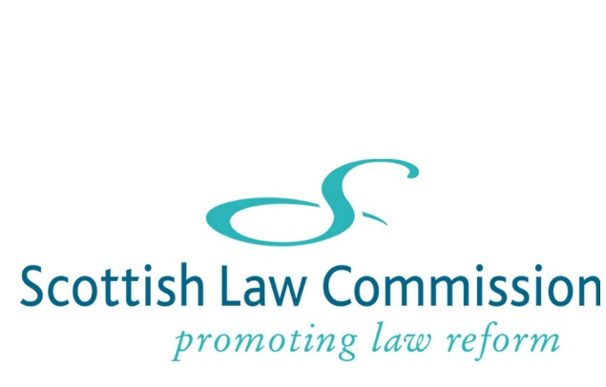

SCOTTISH LAW COMMISSION
ELEVENTH PROGRAMME OF LAW REFORM: CONSULTATION
Introduction
- The Scottish Law Commission is seeking suggestions for suitable law reform projects for our next Programme of Law Reform, our Eleventh Programme. It will commence in 2023.
- The Commission would greatly value any suggestions or comments that you may have. The consultation period closes on 29 July 2022.

The Commission’s current Programme, the Tenth Programme of Law Reform (Scot Law Com No 250), was published in February 2018 and runs until the end of 2022. The Programme can be viewed on our website, at the following link: https://www.scotlawcom.gov.uk/files/5615/1922/5058/Tenth_Programme_of_Law_Reform_Scot_Law_Com_No_250.PDF.
- We will submit a draft of the Eleventh Programme to Scottish Ministers for approval, and laying before the Scottish Parliament.
The context
- In preparing for the Eleventh Programme, the Commission will have regard to the Scottish Government's National Performance Framework, which aims to:
- create a more successful country
- give opportunities to all people living in Scotland
- increase the wellbeing of people living in Scotland
- create sustainable and inclusive growth
- reduce inequalities and give equal importance to economic, environmental and social progress.

The Commission’s remit covers all of Scots law, both reserved and devolved areas of the law. Reform may be needed because the law is causing difficulties in practice, for example where the law is unfair, unclear, unduly complex or out-of-date. It may also be desirable in areas where consolidation of existing legislation, or repeal of spent legislation, would be beneficial.
Criteria for selection of topics for the Eleventh Programme
- The selection criteria for the Eleventh Programme are as follows –
- Importance: The extent to which the law is unjust or out of date (for example, unfair, unclear, inaccessible, inefficient, unduly complex or outdated); and the potential benefits likely to arise from reform of the law.
- Suitability: Whether the issues concerned are predominantly legal rather than political; and whether there is any other body better placed to examine the topic in question.
- Resources: The expertise and experience of Commissioners and legal staff and, in relation to projects where there may be a substantial role for a consultant, the availability of adequate funding; and the need for a mix of projects in terms of scale and timing in order to achieve a balance of workload among Commissioners and facilitate effective management of the Programme.
The Commission will also bear in mind whether a Bill on the topic may be suitable for the special parliamentary law reform processes, in particular the procedure for certain Commission Bills in the Scottish Parliament which is described below.
Projects to be carried forward into the Eleventh Programme
- A number of projects under the Tenth Programme will be carried forward into the Eleventh Programme in 2023. These are –
- Homicide
- Heritable securities
- Damages for personal injury
- Aspects of family law.

- Further details of these projects can be found on our website: http://www.scotlawcom.gov.uk/law-reform-projects/.
- Also, in January 2022 the Cabinet Secretary for Social Justice, Housing and Local Government made a reference to the Commission to undertake a review of tenement law in connection with compulsory owners’ associations.
- As regards law reform work with other Law Commissions, the Commission may continue to work on joint law reform projects with the Law Commission for England and Wales.
- In considering the content of the Eleventh Programme, the Commission needs to take account of our existing workload, together with any joint law reform projects.
Projects intended for special Parliamentary processes for law reform
- The Commission has worked for a number of years with the Scottish Government and the Scottish Parliament to improve planning for implementation of Commission Reports, and to put in place further mechanisms to improve the rate of implementation.
- This resulted in the Scottish Parliament introducing a procedure to improve consideration of certain Commission Bills. These can now be dealt with by the Delegated Powers and Law Reform Committee. The criteria set by the Presiding Officer for such a Bill were revised in March 2022 and apply to bills whose primary purpose is to:-
“(a) simplify, modernise or improve the law to—
(i) ensure it is fit for purpose,
(ii) respond to developments, or address deficiencies, in the common law, or
(iii) respond to other developments in the law;
(b) make provision which is not likely to generate substantial controversy among stakeholders.”
- As part of our business planning and our law reform methodology, the Commission considers that it is important to take account of the procedure and to identify projects that may produce draft legislation suitable for it. We would wish to stress, however, that the procedure will not be suitable for all Commission Bills. We envisage that some Commission Bills will continue to go through the conventional Parliamentary procedures, with the lead committee being the Equalities, Human Rights and Civil Justice Committee, or the Criminal Justice Committee, or one of the other subject committees.
- In the UK Parliament in Westminster, there is also a special procedure for certain Law Commission Bills, including Scottish Law Commission Bills, in the House of Lords. The procedure is available for uncontroversial law reform measures.
- The Commission would be grateful for any suggestions by consultees for a law reform project for the Commission Bill process in the Scottish Parliament; and for a project addressing an issue of Scots law reserved to the UK Parliament that may be a suitable candidate for the House of Lords procedure for Commission Bills.
Conclusion
- The Commission would be grateful for your suggestions and comments on the content of the Eleventh Programme of Law Reform. In particular –
1. Do you have any law reform projects to suggest?
2. Do you have any project to suggest that would be suitable for the Commission Bill process in the Scottish Parliament; or, in relation to reserved matters, for the House of Lords procedure for Commission Bills?
- If suggesting a new project, the Commission would be grateful if you could also provide us with information about:
- the problems and weaknesses with the law that you have identified;
- the impact this is having in practice; and
- the potential benefits of law reform.

A response form is attached below.

THE SCOTTISH LAW COMMISSION
MAY 2022

RESPONSE FORM

PREPARATION OF THE ELEVENTH PROGRAMME OF LAW REFORM

We hope that by using this form it will be easier for you to respond to the questions set out above in the consultation paper. Respondents who wish to address only some of the questions may do so. The form allows you to enter comments in a box after each one. At the end of the form there is also space for any general comments you may have.

Please note that information about this consultation paper, including copies of responses, may be made available in terms of the Freedom of Information (Scotland) Act 2002. Any confidential response will be dealt with in accordance with the 2002 Act.

We may also (i) publish responses on our website (either in full or in some other way such as re-formatted or summarised); and (ii) attribute comments and publish a list of respondents' names.

In order to access any box for comments, press the shortcut key F11 and it will take you to the next box you wish to enter text into. If you are commenting on only one or two of the questions, continue using F11 until you arrive at the box you wish to access. To return to a previous box press Ctrl+Page Up or press Ctrl+Home to return to the beginning of the form.

Please save the completed response form to your own system as a Word document and send it as an email attachment to info@scotlawcom.gov.uk. Comments not on the response form may be submitted via that email address or by using the general comments form on our website. If you prefer you can send comments by post to the Scottish Law Commission, 140 Causewayside, Edinburgh EH9 1PR.

Name:

«InsertTextHere»

Organisation:

«InsertTextHere»

Address:

«InsertTextHere»

Email address:

«InsertTextHere»
Questions

1. Do you have any suitable law reform projects to suggest?
«InsertTextHere»

2. If suggesting a new project:-
(a) Please provide us with information about the issues with the law that you have identified:
«InsertTextHere»

(b) Please provide us with information about the impact this is having in practice:
«InsertTextHere»

(c) Please provide us with information about the potential benefits of law reform:
«InsertTextHere»

3. Do you consider that your suggested law reform project would be suitable for the law reform process in the Scottish Parliament; or, in relation to reserved matters, for the House of Lords procedure for Commission Bills?
«InsertTextHere»

Any Other Comments
«InsertTextHere»

Thank you for taking the time to respond to this consultation paper. Your suggestions and comments are appreciated and will be taken into consideration when preparing our Eleventh Programme of Law Reform.

